A] On First hit After Clearing cache

1. **Without Memcached**

Executed 79 queries in 1601.35 ms. Queries exceeding 5 ms are highlighted. Page execution time was 7051.1 ms. Memory used at: devel_boot()=**1.44** MB, devel_shutdown()=**12.34** MB, PHP peak=**12.75** MB.

1. **With Memcached [with default port only]**

Executed 73 queries in 736.56 ms. Queries exceeding 5 ms are highlighted. Page execution time was 1380.11 ms. Memory used at: devel_boot()=**1.45** MB, devel_shutdown()=**11.52** MB, PHP peak=**12** MB.

**Memcache statistics**

| **operation** | **total ms** | **total hits** | **total misses** |
| --- | --- | --- | --- |
| get | 34.48 | 35 (100.0%) | 0 (0.0%) |
| getMulti | 2.60 | 6 (100.0%) | 0 (0.0%) |
| set | 27.12 | 26 (100.0%) | 1. (0.0%) |

1. **With Memcached[with multiple port like default,page,filter,menu]**

Executed 28 queries in 24.75 ms. Queries exceeding 5 ms are highlighted. Page execution time was 609.62 ms. Memory used at: devel_boot()=**1.45** MB, devel_shutdown()=**9.74** MB, PHP peak=**10** MB.

**Memcache statistics**

|  |  |  |  |
| --- | --- | --- | --- |
| **operation** | **total ms** | **total hits** | **total misses** |
| get | 273.66 | 24 (96.0%) | 1 (4.0%) |
| set | 0.46 | 1 (100.0%) | 0 (0.0%) |
| getMulti | 9.79 | 6 (100.0%) | 0 (0.0%) |
|  |  |  |  |

B] On Successive hit

1. **Without Memcached**

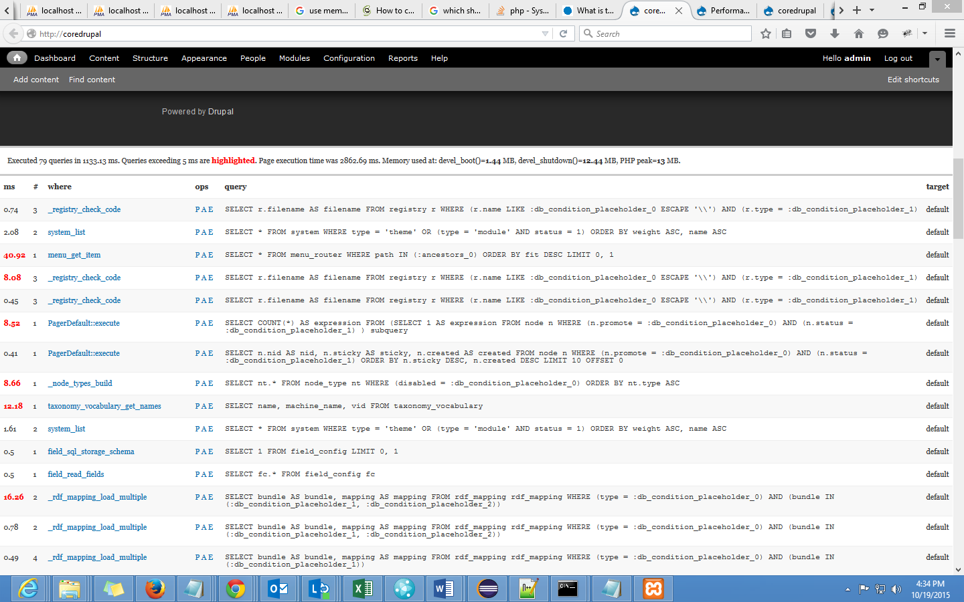

Executed 79 queries in 1133.13 ms. Queries exceeding 5 ms are highlighted. Page execution time was 2862.69 ms. Memory used at: devel_boot()=**1.44** MB, devel_shutdown()=**12.44** MB, PHP peak=**13** MB.

**Concurrent user Testing**

***>>ab -n 500 -c 30*** [***http://coredrupal/***](http://coredrupal/)

C:\xampp\apache\bin>ab -n 500 -c 30 http://coredrupal/

This is ApacheBench, Version 2.3 <$Revision: 1604373 $>

Copyright 1996 Adam Twiss, Zeus Technology Ltd, http://www.zeustech.net/

Licensed to The Apache Software Foundation, http://www.apache.org/

Benchmarking coredrupal (be patient)

Completed 100 requests

Completed 200 requests

Completed 300 requests

Completed 400 requests

Completed 500 requests

Finished 500 requests

Server Software: Apache/2.4.10

Server Hostname: coredrupal

Server Port: 80

Document Path: /

Document Length: 9741 bytes

Concurrency Level: 30

Time taken for tests: 164.740 seconds

Complete requests: 500

Failed requests: 38

(Connect: 0, Receive: 0, Length: 38, Exceptions: 0)

Non-2xx responses: 29

Total transferred: 4890586 bytes

HTML transferred: 4707819 bytes

Requests per second: 3.04 [#/sec] (mean)

Time per request: 9884.428 [ms] (mean)

Time per request: 329.481 [ms] (mean, across all concurrent requests)

Transfer rate: 28.99 [Kbytes/sec] received

**Connection Times (ms)**

**min mean[+/-sd] median max**

**Connect: 0 1 2.6 1 59**

**Processing: 2157 9501 6065.9 7646 52111**

**Waiting: 2084 8925 6037.4 6985 50989**

**Total: 2158 9502 6065.8 7647 52112**

Percentage of the requests served within a certain time (ms)

50% 7647

66% 10281

75% 12621

80% 13348

90% 17399

95% 20709

98% 24850

99% 33195

100% 52112 (longest request)

1. **With Memcached [with default port only]**

'memcache_servers' => array('10.44.54.1:11211' => 'default',

),

'memcache_bins' => array('cache' => 'default',

),

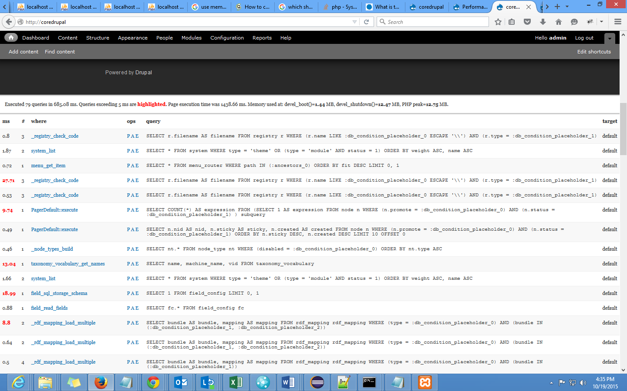

Executed 79 queries in 685.08 ms. Queries exceeding 5 ms are highlighted. Page execution time was 1438.66 ms. Memory used at: devel_boot()=**1.44** MB, devel_shutdown()=**12.47** MB, PHP peak=**12.75** MB.

| **Memcache statistics** |  |  |  |
| --- | --- | --- | --- |

| **operation** | **total ms** | **total hits** | **total misses** |
| --- | --- | --- | --- |
| get | 31.67 | 36 (94.7%) | 2 (5.3%) |
| getMulti | 2.67 | 6 (85.7%) | 1 (14.3%) |
| set | 8.59 | 11 (100.0%) | 0 (0.0%) |
| delete | 1.90 | 3 (50.0%) | 3 (50.0%) |

**Concurrent user Testing**

***>> ab -n 500 -c 30*** [***http://coredrupalmem/***](http://coredrupalmem/)

C:\xampp\apache\bin>ab -n 500 -c 30 http://coredrupalmem/

This is ApacheBench, Version 2.3 <$Revision: 1604373 $>

Copyright 1996 Adam Twiss, Zeus Technology Ltd, http://www.zeustech.net/

Licensed to The Apache Software Foundation, http://www.apache.org/

Benchmarking coredrupalmem (be patient)

Completed 100 requests

Completed 200 requests

Completed 300 requests

Completed 400 requests

Completed 500 requests

Finished 500 requests

Server Software: Apache/2.4.10

Server Hostname: coredrupalmem

Server Port: 80

Document Path: /

Document Length: 9813 bytes

Concurrency Level: 30

Time taken for tests: 60.280 seconds

Complete requests: 500

Failed requests: 0

Total transferred: 5091500 bytes

HTML transferred: 4906500 bytes

Requests per second: 8.29 [#/sec] (mean)

Time per request: 3616.820 [ms] (mean)

Time per request: 120.561 [ms] (mean, across all concurrent requests)

Transfer rate: 82.48 [Kbytes/sec] received

Connection Times (ms)

min mean[+/-sd] median max

Connect: 0 1 0.6 1 9

**Processing: 1545 3575 1612.3 2956 8555**

**Waiting: 1404 3245 1315.6 2839 7059**

**Total: 1546 3576 1612.4 2957 8556**

Percentage of the requests served within a certain time (ms)

50% 2957

66% 3753

75% 4890

80% 5194

90% 6304

95% 6729

98% 7261

99% 7472

100% 8556 (longest request)

1. **With Memcached[with multiple port like default,page,filter,menu]**

'memcache_servers' => array('10.44.54.1:11211' => 'default',

'10.44.54.1:11212' => 'page',

'10.44.54.1:11213' => 'filter',

'10.44.54.1:11214' => 'menu'

),

'memcache_bins' => array('cache' => 'default',

'cache_page' => 'page',

'cache_filter' => 'filter',

'cache_menu' => 'menu'

),

**Performance report**

Executed 28 queries in 24.75 ms. Queries exceeding 5 ms are highlighted. Page execution time was 609.62 ms. Memory used at: devel_boot()=**1.45** MB, devel_shutdown()=**9.74** MB, PHP peak=**10** MB.

| **Memcache statistics** |  |  |  |
| --- | --- | --- | --- |

| **operation** | **total ms** | **total hits** | **total misses** |
| --- | --- | --- | --- |
| get | 273.66 | 24 (96.0%) | 1 (4.0%) |
| set | 0.46 | 1 (100.0%) | 0 (0.0%) |
| getMulti | 9.79 | 6 (100.0%) | 0 (0.0%) |

**Concurrent user Testing**

***>>ab -n 500 -c 30*** [***http://coredrupalmem/***](http://coredrupalmem/)

C:\xampp\apache\bin>ab -n 500 -c 30 http://coredrupalmem/

This is ApacheBench, Version 2.3 <$Revision: 1604373 $>

Copyright 1996 Adam Twiss, Zeus Technology Ltd, http://www.zeustech.net/

Licensed to The Apache Software Foundation, http://www.apache.org/

Benchmarking coredrupalmem (be patient)

Completed 100 requests

Completed 200 requests

Completed 300 requests

Completed 400 requests

Completed 500 requests

Finished 500 requests

Server Software: Apache/2.4.10

Server Hostname: coredrupalmem

Server Port: 80

Document Path: /

Document Length: 9813 bytes

Concurrency Level: 30

Time taken for tests: 50.829 seconds

Complete requests: 500

Failed requests: 0

Total transferred: 5091500 bytes

HTML transferred: 4906500 bytes

Requests per second: 9.84 [#/sec] (mean)

Time per request: 3049.711 [ms] (mean)

Time per request: 101.657 [ms] (mean, across all concurrent requests)

Transfer rate: 97.82 [Kbytes/sec] received

Connection Times (ms)

min mean[+/-sd] median max

Connect: 0 1 0.5 1 3

**Processing: 1545 3001 1019.3 2620 6877**

**Waiting: 1490 2961 1005.0 2587 6735**

**Total: 1546 3002 1019.3 2620 6878**

Percentage of the requests served within a certain time (ms)

50% 2620

66% 3030

75% 3285

80% 3683

90% 4634

95% 5423

98% 6054

99% 6338

100% 6878 (longest request)

**Memcache statistics status report**

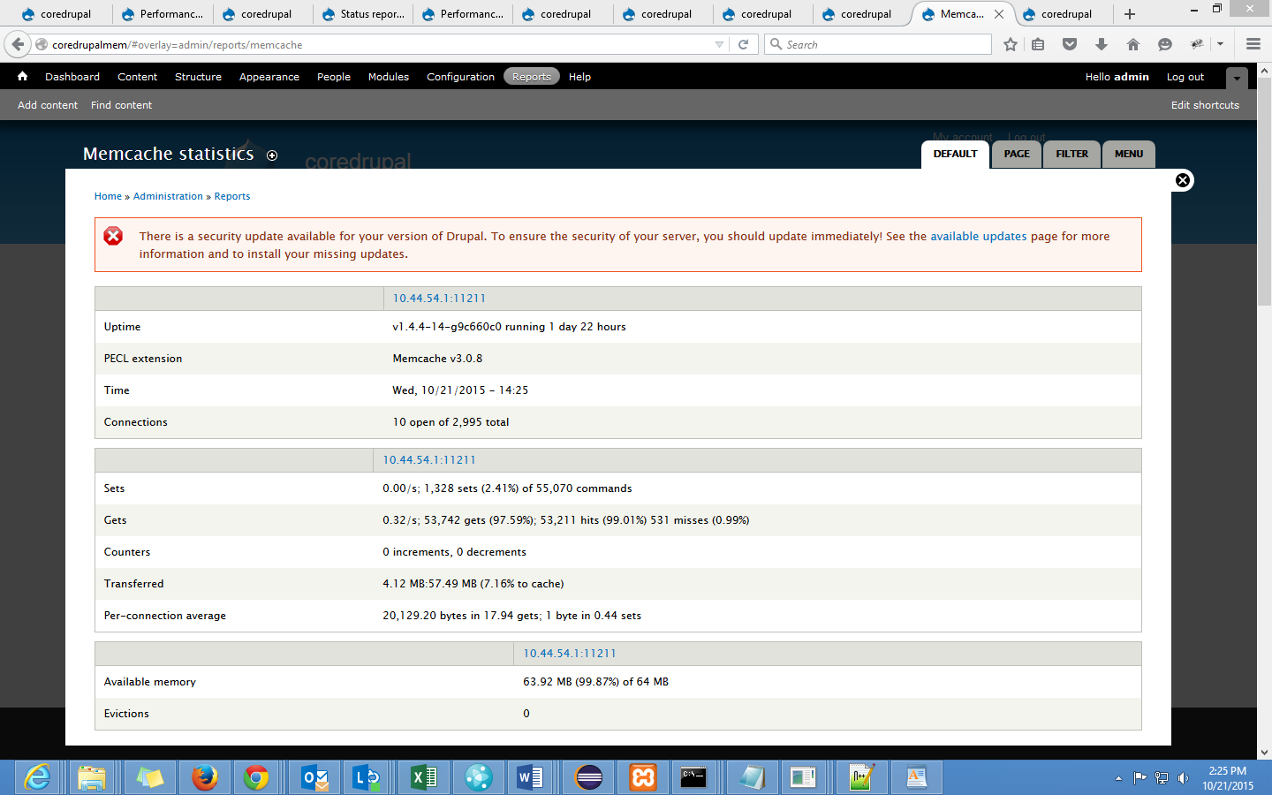

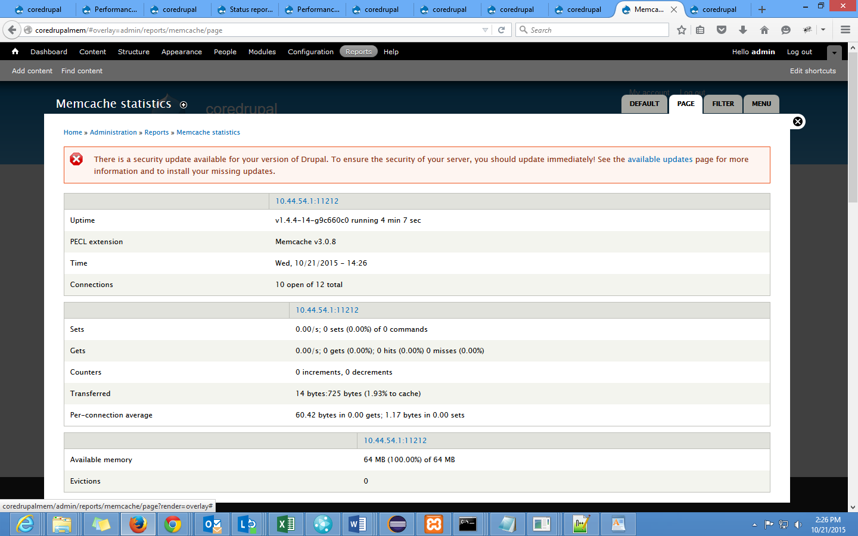

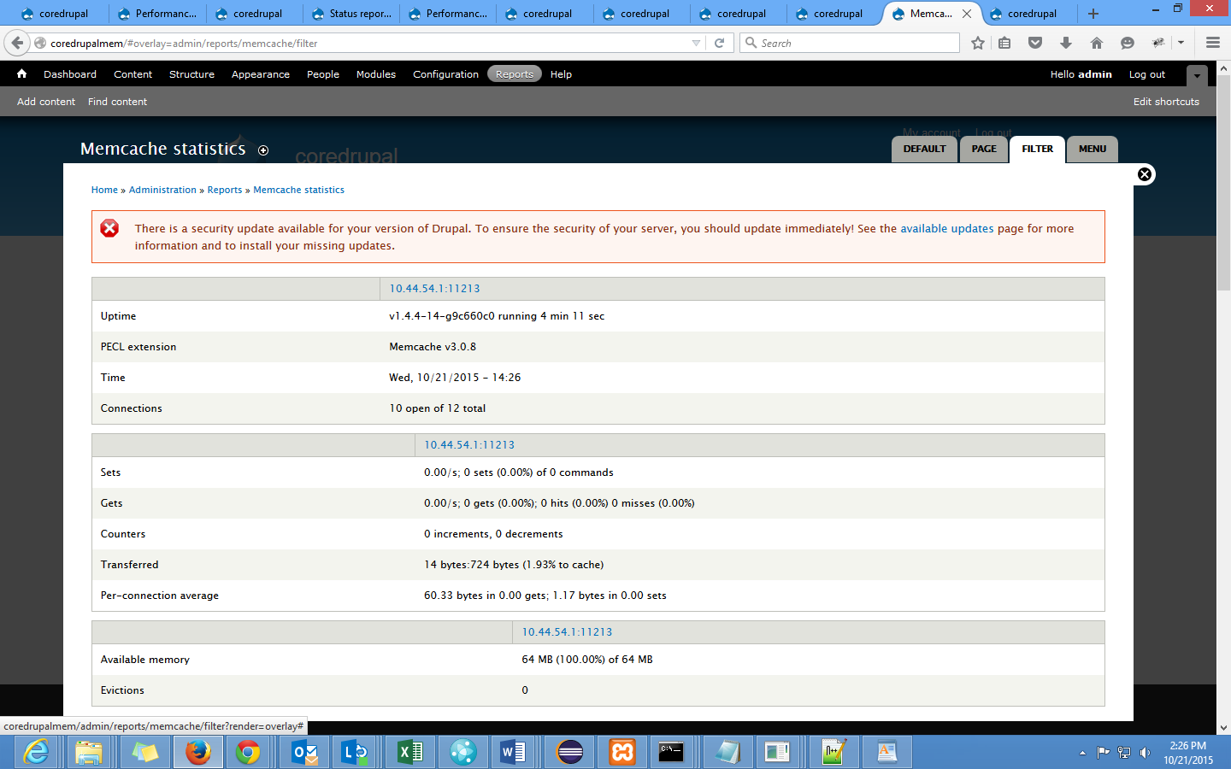

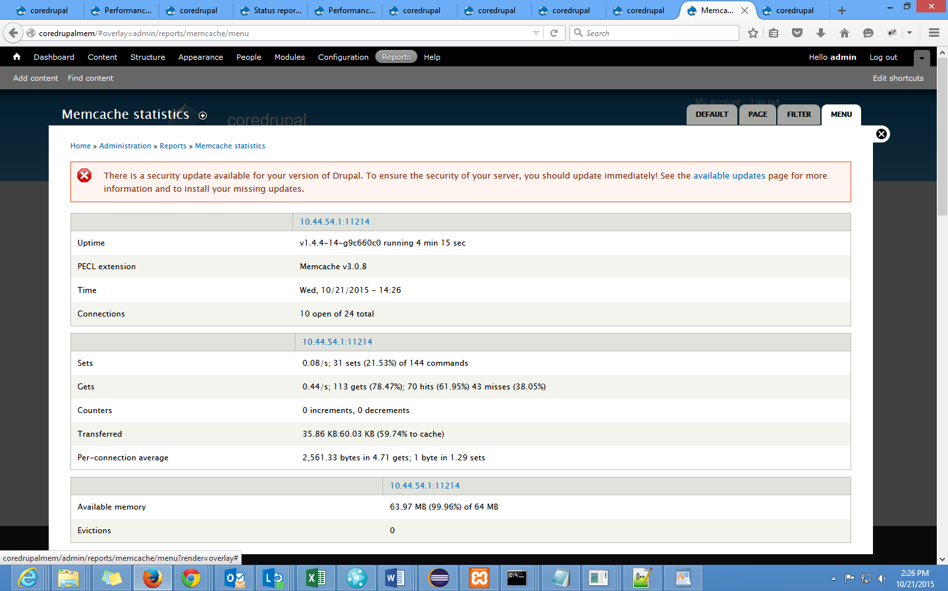

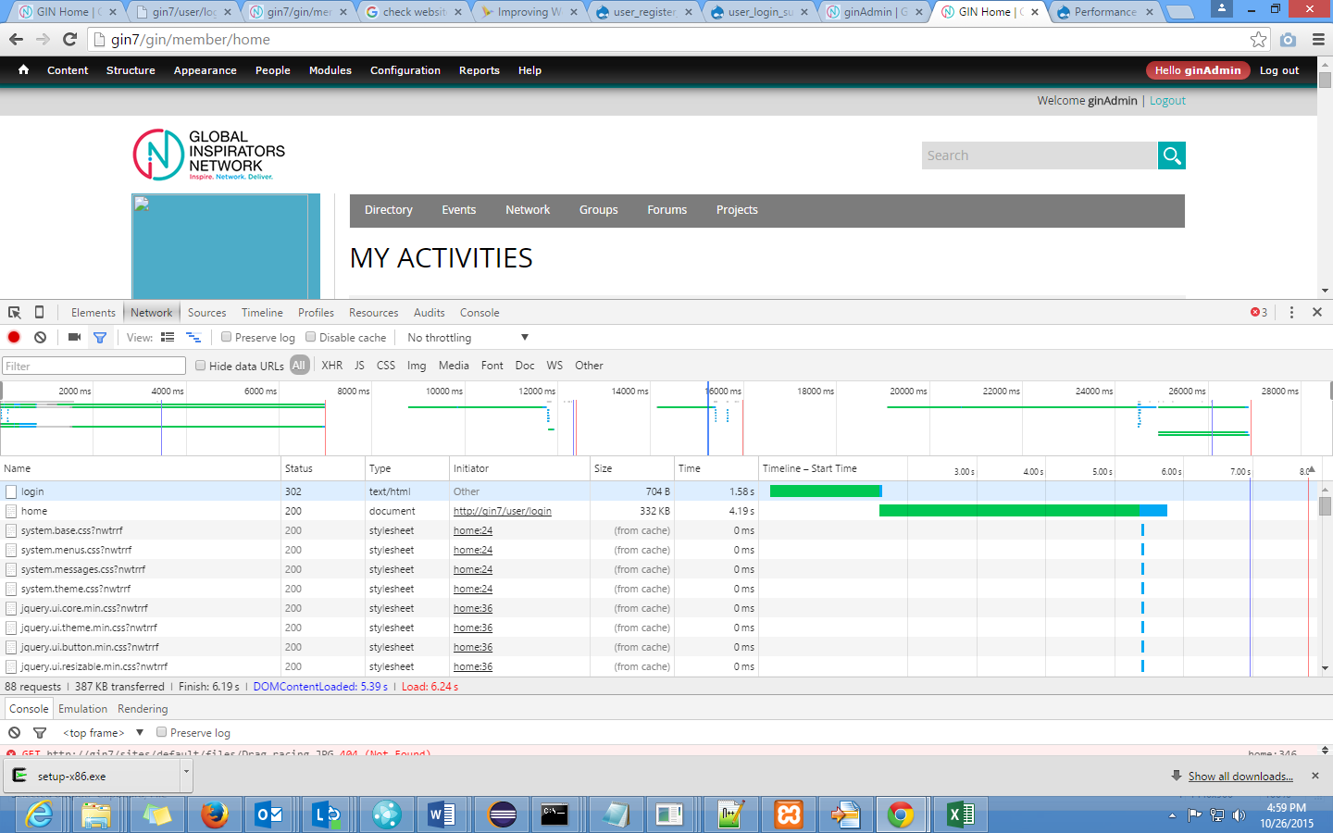

|  |
| --- |
|  |
| login | 302 | text/html | Other | 704 B | 1.69 s |  |  |
| home | 200 | document | <http://gin7/user/login> | 329 KB | 4.00 s |  |  |
| system.base.css?nwtrrf | 200 | stylesheet | [home:24](http://gin7/gin/member/home) | (from cache) | 1 ms |  |  |

|  |
| --- |
|  |
| login | 302 | text/html | Other | 704 B | 1.69 s |  |  |
| home | 200 | document | <http://gin7/user/login> | 329 KB | 4.00 s |  |  |
| system.base.css?nwtrrf | 200 | stylesheet | [home:24](http://gin7/gin/member/home) | (from cache) | 1 ms |  |  |

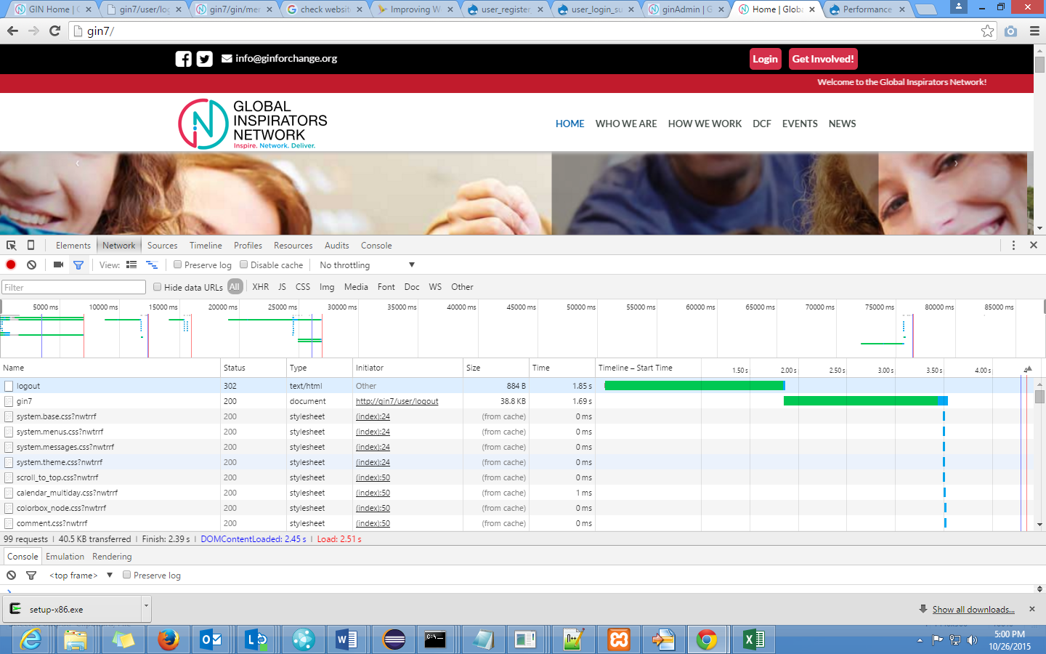

|  |  |  |  |  |  |  |  |  |  |  |  |  |  |  |
| --- | --- | --- | --- | --- | --- | --- | --- | --- | --- | --- | --- | --- | --- | --- |
| logout | | | | | | | | | 302 | text/html | Other | 884 B | 1.85 s |  |
|  |
| logout | 302 | text/html | Other | 884 B | 1.85 s |  |  |
| gin7 | 200 | document | <http://gin7/user/logout> | 38.8 KB | 1.69 s |  |  |
| system.base.css?nwtrrf | 200 | stylesheet | [(index):24](http://gin7/) | (from cache) | 0 ms |  |  |

|  |  |  |  |  |  |  |  |
| --- | --- | --- | --- | --- | --- | --- | --- |
| Logout | 302 | text/html | Other | 884 B | 1.21 s |  |  |
| gin7 | 200 | document | <http://gin7/user/logout> | 38.8 KB | 1.69 s |  |  |

**1.21/1.69 –2.18/1.71**

**Login:- 1.36/3.38 1.54/3.18**